Test # | Description | PASS/FAIL
1 | scene.txt | PASS
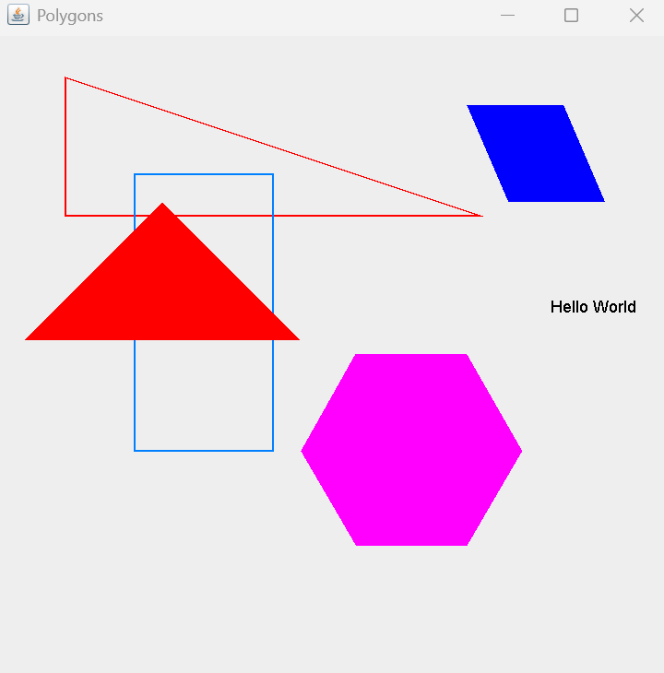
Test # | Description | PASS/FAIL
2 | Scene PolygonTest.txt | PASS
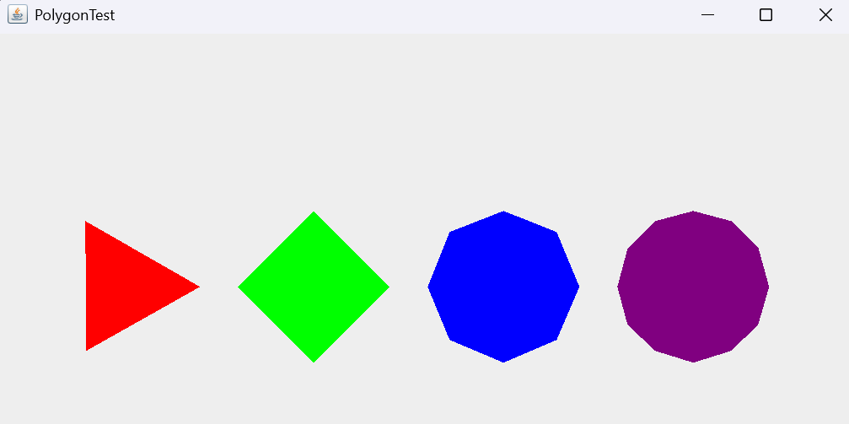

Test # | Description | PASS/FAIL
3 | Scene TextTest.txt | PASS
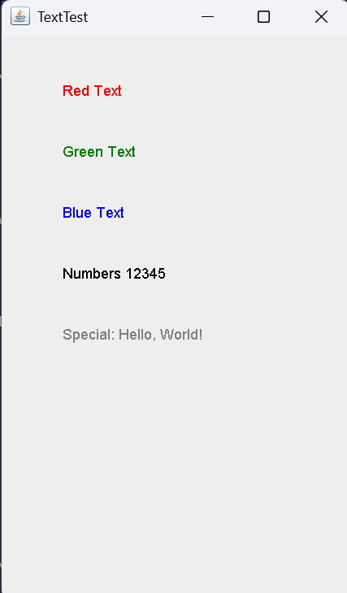
Test # | Description | PASS/FAIL
4 | Scene ParallelogramTest.txt | PASS
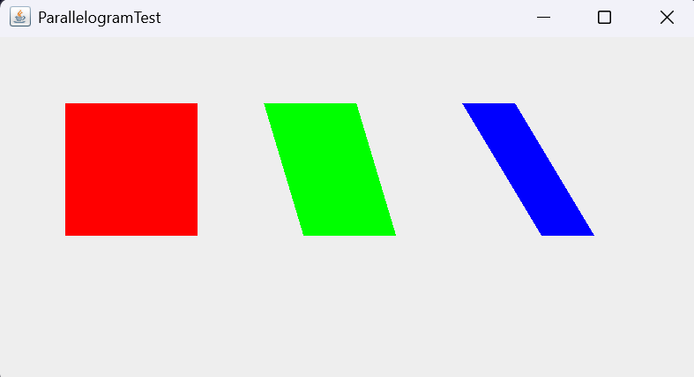
Test # | Description | PASS/FAIL
5 | Scene IsoscelesTest.txt | PASS
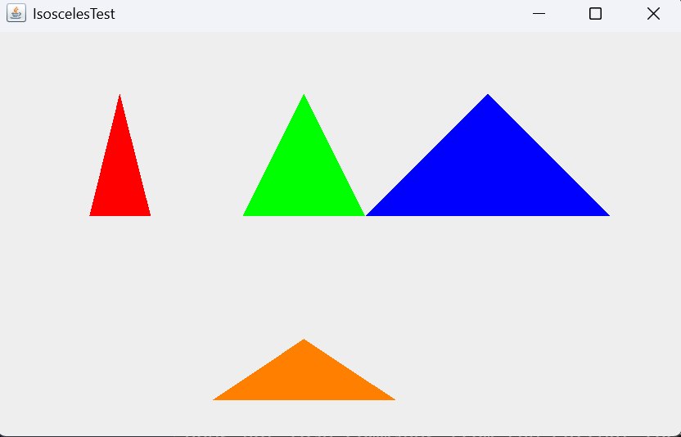
Test # | Description | PASS/FAIL
6 | Scene ErrorTest.txt | PASS
Test # | Description | PASS/FAIL
7 | Scene LargeCoords.txt | PASS
